STUDENT PERFORMANCE ANALYSIS
Exploratory Data Analysis (EDA) using Python
A Personal Data Analysis Project — Built with Python
Author | Aliya Batool
Project Type | Personal Portfolio Project
Tools & Technologies | Python, Pandas, NumPy, Matplotlib, Seaborn, Jupyter Notebook
Project Date | July 2026
GitHub Repository | https://github.com/student-Aliya/Student-Performance-Analysis

Contents
1. Introduction 3
2. Project Objectives 3
3. Dataset Description 3
3.1 Column Overview 3
4. Project Workflow 4
5. Tools and Libraries 4
6. Data Cleaning 4
7. Exploratory Data Analysis 6
7.1 Histogram — GPA Distribution 6
7.2 Box Plot — GPA Spread & Outliers 6
7.3 Count Plot — Gender Distribution 7
7.4 Scatter Plot — Study Time vs GPA 7
7.5 Correlation Heatmap 8
7.6 Pair Plot 9
8. Key Findings 11
9. Conclusion 11
10. Future Improvements 11
11. References 12

1. Introduction
Academic performance is shaped by a mix of behavioural, social, and demographic factors, and understanding those factors is a common first step before building any predictive model. This project performs a complete Exploratory Data Analysis (EDA) on a student performance dataset using Python, with the goal of understanding the structure of the data, spotting patterns, and visualising relationships between variables before drawing any conclusions.
The analysis follows a standard data science workflow: loading the dataset, inspecting its structure, cleaning it, and then using statistical summaries and visualisations (histograms, box plots, count plots, scatter plots, a correlation heatmap, and a pair plot) to extract meaningful insights about what is associated with higher or lower GPA.

2. Project Objectives
- Understand the structure, data types, and quality of the student performance dataset.
- Clean the dataset by checking for missing values and duplicate records.
- Visualise the distribution of GPA and other key variables.
- Explore the relationship between study time, absences, and academic performance (GPA).
- Identify correlations between numerical features using a correlation heatmap and pair plot.
- Summarise actionable insights that could inform further modelling or intervention.

3. Dataset Description
The dataset used for this project is the Student Performance Data set, containing 2,392 student records across 15 columns covering demographic information, study habits, parental involvement, extracurricular activity, and academic outcome.

3.1 Column Overview
- StudentID — unique identifier assigned to each student.
- Age — student age, ranging from 15 to 18 years.
- Gender — coded categorical variable (0 / 1).
- Ethnicity — coded categorical variable (0–3).
- ParentalEducation — coded ordinal variable representing parental education level (0–4).
- StudyTimeWeekly — hours spent studying per week (continuous, 0–20).
- Absences — number of absences recorded (0–29).
- Tutoring — whether the student receives tutoring (0 = No, 1 = Yes).
- ParentalSupport — coded ordinal variable for level of parental support (0–4).
- Extracurricular, Sports, Music, Volunteering — binary flags (0/1) for participation.
- GPA — the student's grade point average (continuous, 0–4); the primary outcome variable.
- GradeClass — coded categorical grade bracket derived from GPA (0–4).
All categorical variables in this dataset are numerically encoded rather than provided as text labels. Where the exact label mapping was not confirmed against a data dictionary, this report describes categories by their numeric codes rather than assuming a label, to avoid misrepresenting the data.

4. Project Workflow
- Import required libraries (Pandas, NumPy, Matplotlib, Seaborn) and load the dataset with Pandas.
- Inspect the data using .head(), .shape, .columns, .info(), and .describe() to understand structure and data types.
- Clean the data by checking for missing values with .isnull().sum() and duplicate rows with .duplicated().sum().
- Examine the categorical Gender column with .value_counts() to check class balance.
- Visualise GPA distribution using a histogram with KDE overlay, and check for outliers using a box plot.
- Visualise the Gender split using a count plot.
- Explore the relationship between Study Time Weekly and GPA using a scatter plot.
- Compute pairwise correlations across numeric features and visualise them with a heatmap.
- Use a pair plot to jointly examine GPA, StudyTimeWeekly, Absences, and Age.
- Summarise the findings into key insights and a conclusion.

5. Tools and Libraries
- Python — core programming language for the analysis.
- Pandas — data loading, cleaning, and summary statistics.
- NumPy — underlying numerical operations.
- Matplotlib — base plotting engine and figure export.
- Seaborn — statistical visualisations (histplot, boxplot, countplot, scatterplot, heatmap, pairplot).
- Jupyter Notebook — interactive environment used to build and document the analysis.

6. Data Cleaning
Before any visualisation, the dataset was checked for common data quality issues:
- Missing values: df.isnull().sum() confirmed there are no missing values across any of the 15 columns.
- Duplicate records: df.duplicated().sum() confirmed there are no duplicate rows in the dataset.
- Class balance check: df['Gender'].value_counts() showed the two Gender categories are close to evenly split (1,222 vs 1,170 records).
Because the dataset arrived already clean — no missing values and no duplicates — no imputation or row-dropping was required, and the analysis could move directly into exploration

7. Exploratory Data Analysis
This section presents each visualisation generated in the notebook, alongside what it shows about the dataset.

7.1 Histogram — GPA Distribution
A histogram with a KDE (kernel density estimate) overlay was used to see how GPA is distributed across all 2,392 students.
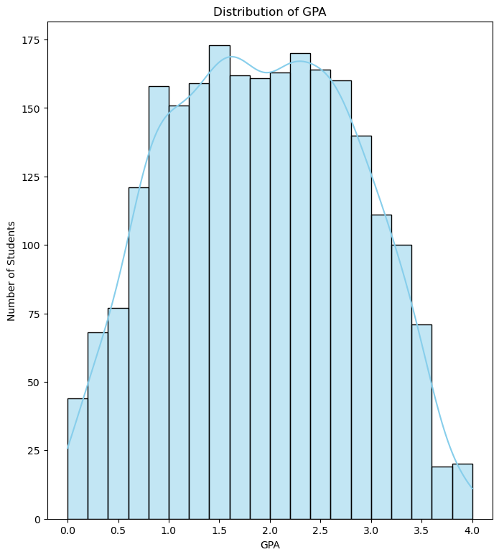
Figure 1: Distribution of GPA across students, with KDE curve overlay.
The GPA values range from 0 to 4, with a mean of about 1.91 and a standard deviation of 0.92. Most students fall between roughly 1.5 and 3.0, and the distribution is right-skewed rather than centred near the maximum, meaning higher GPAs (close to 4.0) are comparatively rare in this dataset.

7.2 Box Plot — GPA Spread & Outliers
A box plot was used to check the spread of GPA values and identify potential outliers.
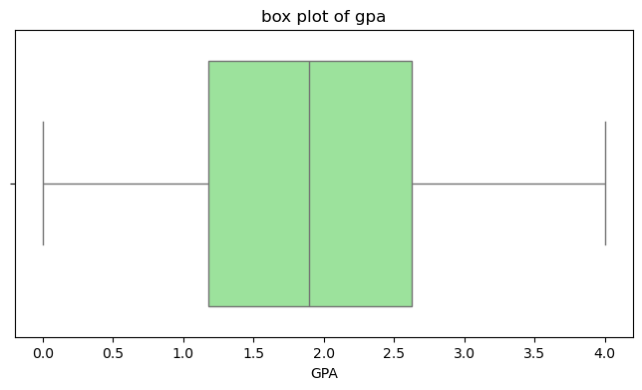
Figure 2: Box plot of GPA showing median, interquartile range, and spread.
The box plot confirms the GPA values are spread fairly evenly through their range (0 to 4) without extreme outliers pulling the distribution in one direction — consistent with the histogram.

7.3 Count Plot — Gender Distribution
A count plot was used to visualise how many students fall into each Gender category.
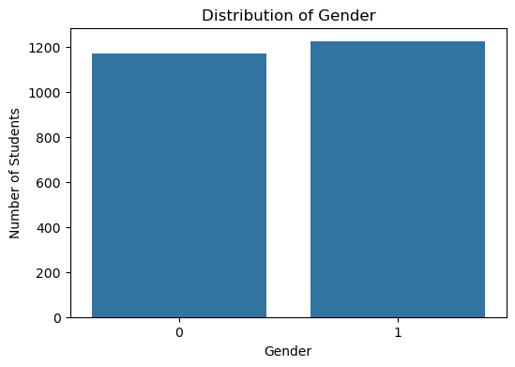
Figure 3: Number of students per Gender category.
The dataset is close to evenly split by Gender (1,222 records coded as 1 versus 1,170 coded as 0), so Gender is not a source of class imbalance in this data.

7.4 Scatter Plot — Study Time vs GPA
A scatter plot was used to visually inspect the relationship between weekly study time and GPA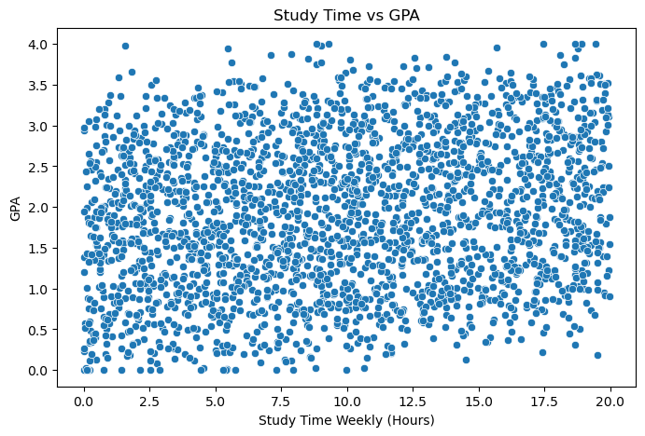
Figure 4: Study Time Weekly (hours) plotted against GPA.
The scatter plot shows a loose upward trend — students who report more weekly study hours tend to have somewhat higher GPA — but the relationship is noisy rather than a tight line, which is confirmed numerically in the correlation heatmap below (correlation ≈ 0.18).

7.5 Correlation Heatmap
A correlation heatmap was generated across all numeric columns to quantify relationships between variables.
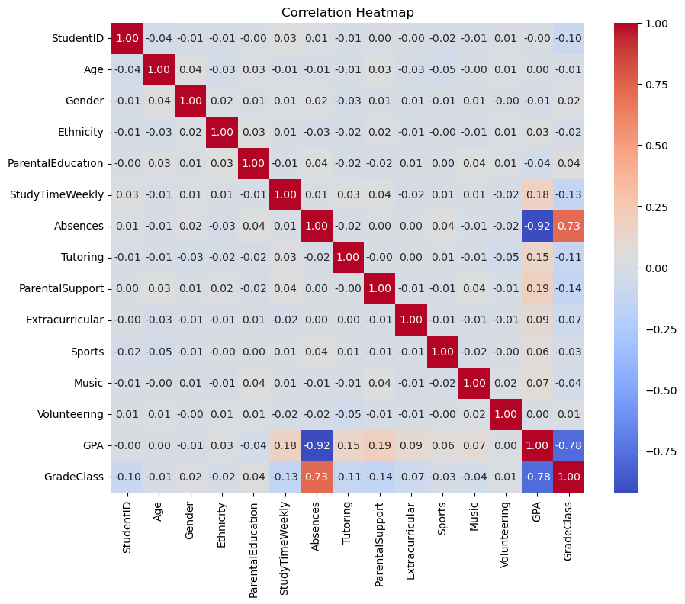
Figure 5: Pearson correlation heatmap of numeric features.
The strongest correlations with GPA are:
- Absences → GPA: −0.92 (strong negative correlation) — by far the biggest driver in the dataset. More absences are very strongly associated with lower GPA.
- GradeClass → GPA: −0.78 (strong negative, expected since GradeClass is derived from GPA bands).
- ParentalSupport → GPA: +0.19 (weak positive).
- StudyTimeWeekly → GPA: +0.18 (weak positive).
- Tutoring → GPA: +0.15 (weak positive).
Age, Gender, Ethnicity, and ParentalEducation all show negligible correlation with GPA (roughly −0.04 to 0.00).

7.6 Pair Plot
A pair plot was generated across GPA, StudyTimeWeekly, Absences, and Age to jointly visualise their pairwise relationships and individual distributions.
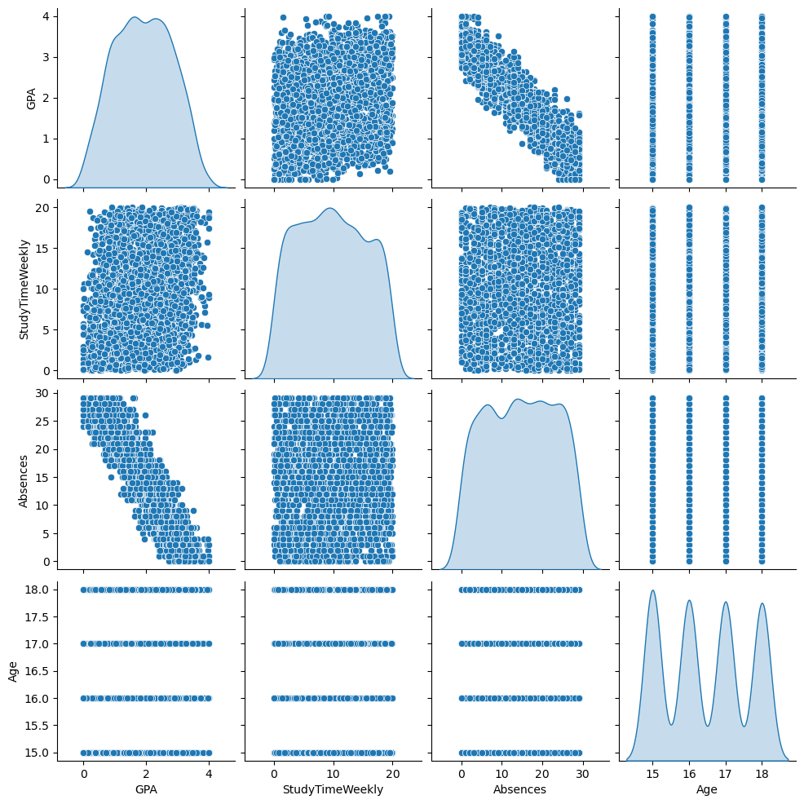
Figure 6: Pair plot of GPA, StudyTimeWeekly, Absences, and Age.
The pair plot reinforces the heatmap findings: the GPA–Absences panel shows a visibly negative trend, the GPA–StudyTimeWeekly panel shows a weak positive trend, and Age shows no clear relationship with GPA — its diagonal distribution is fairly uniform across the 15–18 age range, and its scatter panels against GPA show no visible pattern.

8. Key Findings
- The dataset contains 2,392 student records with no missing values and no duplicate rows, requiring no cleaning before analysis.
- GPA ranges from 0 to 4 with a mean of 1.91 (std. 0.92); most students cluster between roughly 1.5 and 3.0, and very high GPAs are relatively rare.
- Absences is the strongest predictor of GPA in this dataset, with a correlation of −0.92 — students with more absences consistently show lower GPA.
- Weekly study time shows a weak positive relationship with GPA (correlation ≈ 0.18): more study time is associated with somewhat higher GPA, but it is far less influential than attendance.
- Parental support and tutoring show similarly weak positive associations with GPA (correlation ≈ 0.15–0.19).
- Gender distribution is close to balanced (1,222 vs 1,170), and Gender, Age, Ethnicity, and ParentalEducation all show negligible correlation with GPA.
- GradeClass is derived directly from GPA bands, which explains its strong correlation (−0.78) with GPA.

9. Conclusion
This EDA shows that attendance is the single biggest factor associated with academic performance in this dataset — far more than demographic variables like age, gender, or ethnicity, which show almost no relationship with GPA. Study time, tutoring, and parental support each have a modest positive association with GPA, suggesting they matter, but attendance dominates. From a practical standpoint, this points toward absence-reduction as the highest-leverage intervention for improving student outcomes, with study-habit and support-based interventions as secondary levers.

10. Future Improvements
- Build a predictive model (e.g., linear regression or a tree-based model) to estimate GPA from the available features and quantify feature importance beyond simple correlation.
- Confirm the exact label mapping for coded categorical columns (Gender, Ethnicity, ParentalEducation, ParentalSupport, GradeClass) against a data dictionary, and re-express findings in labelled terms.
- Test for interaction effects — for example, whether the positive effect of study time is stronger for students with fewer absences.
- Add statistical significance testing (e.g., correlation p-values, ANOVA across categorical groups) rather than relying on correlation coefficients alone.
- Deploy the analysis as an interactive dashboard (e.g., Streamlit) so the relationships can be explored dynamically.

11. References
- Pandas Documentation — https://pandas.pydata.org/docs/
- NumPy Documentation — https://numpy.org/doc/
- Matplotlib Documentation — https://matplotlib.org/stable/contents.html
- Seaborn Documentation — https://seaborn.pydata.org/
- Dataset: Rabie El Kharoua. Student Performance Dataset. Kaggle. https://www.kaggle.com/datasets/rabieelkharoua/students-performance-dataset

